Assignment-18.3:

Question: Merge the small files in hadoop by following the below blog.

<https://acadgild.com/blog/merging-files-hdfs>

I am creating the Folder named getmerge in the hdfs and I am copying three files into that folder

And in the below screenshots I am displaying those three files

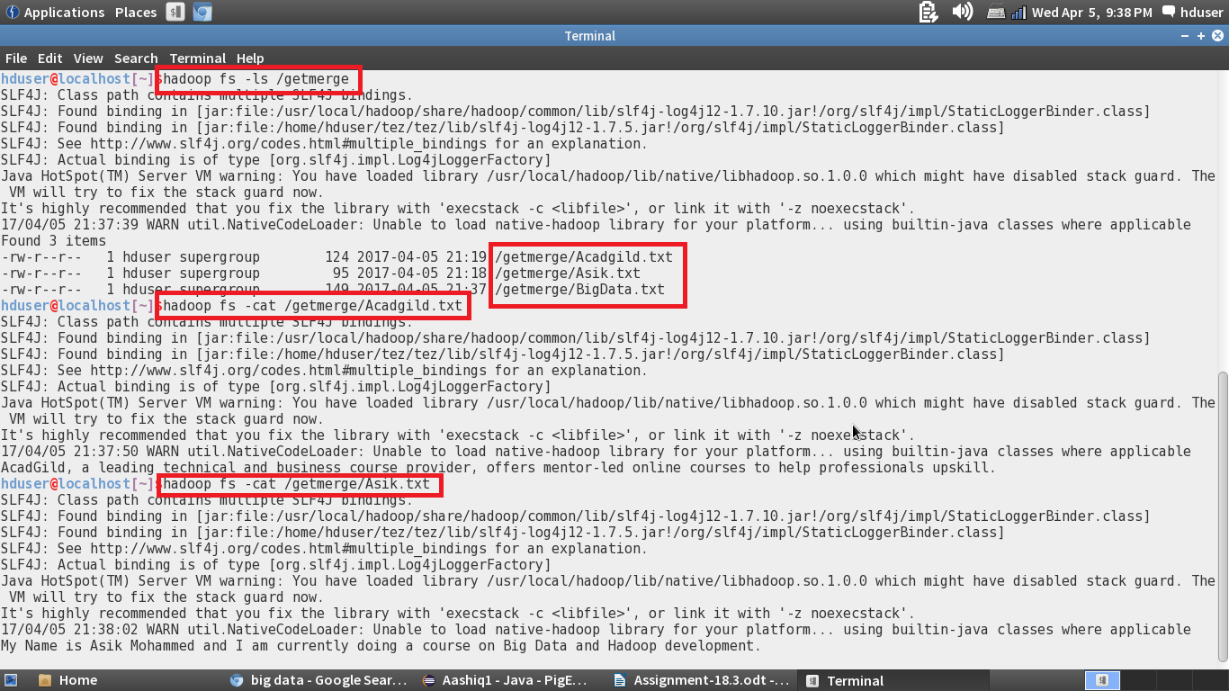

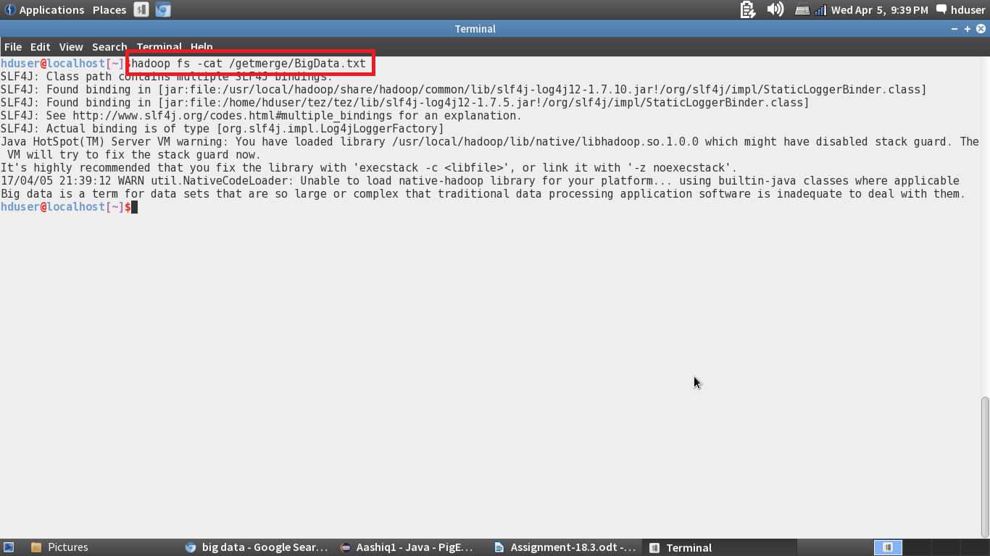

Getmerge command:

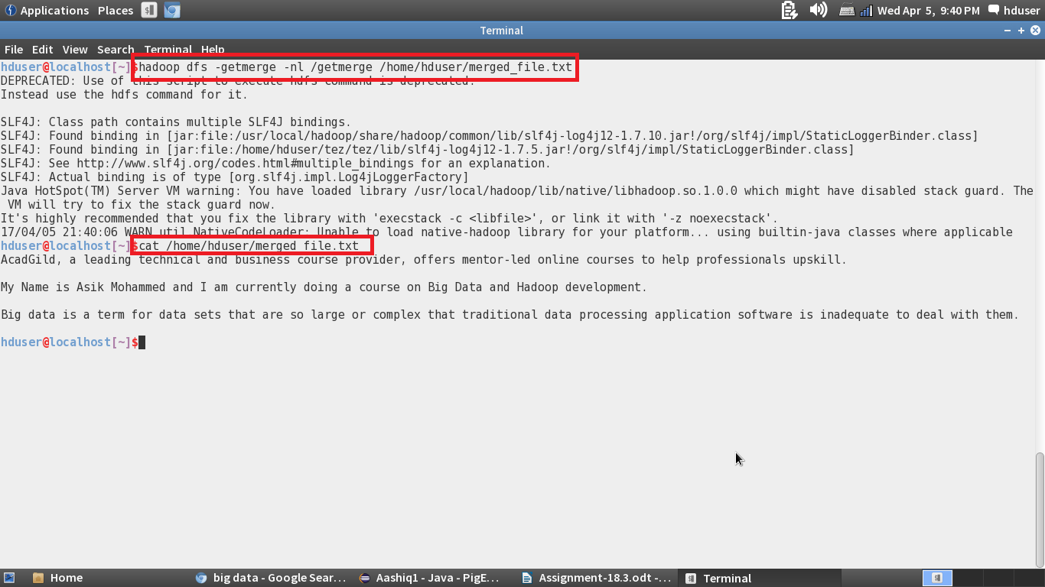

In the above screenshot, I am giving the getmerge command and storing the output in the merged_file.txt and I am displaying the merged text file, we can see that the files are merged.